Assets Library

Table of Contents

Stimulus 2

Ideas 2

Models 3

Legal and ethical considerations 8

# Stimulus

**Client brief**

The aim of this project is to design and create 3D models, which would be used as game assets in *Pirates Ship*. As requested from the client, I was asked to model five objects representative of the game’s theme, along with its logo.

**The Game -** *Pirates Ship*

This role-playing game takes place in a world of fantasy, where the playing character wakes up in a remote island. As it seems that he lost his memories, the recently awoke individual finds himself drowned in feelings ranging between confusion and disorientation, and spots an abandoned old ship from a distance. Once inside the eerie looking ship, curiosity starts to taste bitter as soon as the doors are shut from outside. After some failed attempts, the character realises he is trapped inside the ship.

# Ideas

The 3D models will be used in the client’s game. According to the context, the models are characteristic of the game concept and **what the player will need**, either it is to survive or search for clues to escape the haunted ship.

**Brainstorms**

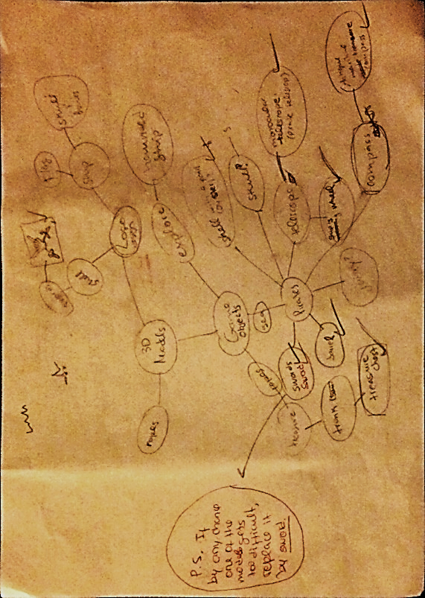Before I came upon the decision of the models I would create, I used brainstorms to express my ideas. As these models were meant to be used in a game, I could start ramifying that concept into the first words that came into mind.

As the picture shows, there is no linear flow, but the whole game concept broken down in many other components. From *sea* came *pirates*, and from there all the other expressions that lead me to my 3D models. Using this technique was a good way of organising my ideas and associating terms, since one could write down whatever that comes to mind in the moment and ultimately go back, change or add few things to complement the previous expression.

Figure 1. Brainstorms.

## Models

**Target audience:** 12+**;**

The game does not deliver any content of sensitive nature, so it is firm to say its target audience englobes all groups starting from 12 years of age. The gaming population has incredibly broaden over the years. This fact was taken in consideration when designing the models for the game.

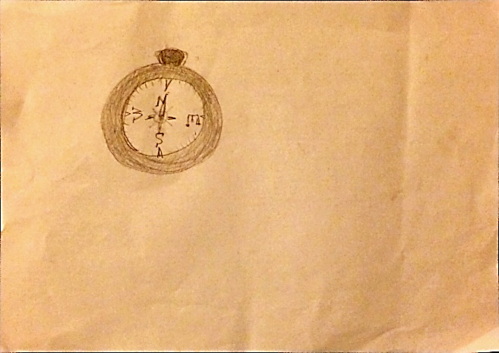**Compass**

Among the models I intend to create, I have chosen a compass. In order to escape, clues will be placed in every corner of the ship. Some clues may require the player to follow a cardinal direction: either north, south, east or west. As directions will be given in these clues, the playing character can easily search for other clues that will lead him out from where he’s got himself trapped. Therefore, this game object is much needed. The model for the navigational compass will be very simple, as shown in *Figure* 2.

Figure 2. Compass sketch.

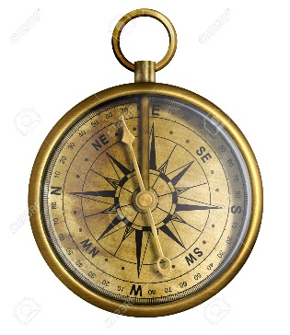Initially, my aim was to create an antique compass that would resemble those that once belonged to the Golden Age of Piracy. These compasses are a little more detailed (*Figure 3*) than the one I have sketched. More complex models show points and bearings, but I decided to only include the 4 essential cardinal directions. The aim of this object is to facilitate player’s escape, and creating a very complex compass wouldn’t be as user- friendly nor accessible. Hence, I thought it best to keep the details of this model to a minimum.

Figure 3. Points and bearings compass.

**Key visual themes**

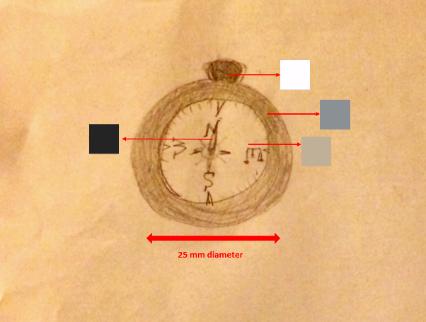

As it is a haunted game, and its **target** **audience** englobes age groups over 12, I have opted for a dull colour palette (these colours were attributed to each different parts of the compass, shown in the picture).

The compass will not be difficult, since I aim for a simple model. This means it **will have a low-poly count**.

This model will have **solid colour textures** as the picture shows.

**Treasure chest**

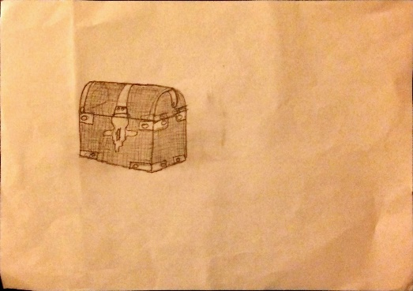The next game asset is a treasure chest. It will contain several objects such as toys, golden coins, clothing and other items in order to hide relevant clues. During the hectic search inside the cabin, the playing character is expected to come across few odd events throughout. As part of the trail of clues, the player will stumble upon this chest, which will unveil hidden secrets and possibly the way out. Additionally, it will provide some background story and perhaps the reason behind the queer, other-worldly happenings that have been taking place in the ship.

Figure 4. Treasure chest.

Contrary to what the sketch demonstrates – *Figure 4* -, I plan to model an open treasure chest. This way, the client can place other objects inside. As I want to make it reasonably realistic, it shouldn’t have to be a complicated model, for it will contain a balanced amount of detail and complexity.

The reason why I am creating a low-poly chest is because the game is set in an enclosed compartment of the ship in which there won’t be much light. Therefore, the player will not pay attention to the details of this game object.

Once again, the textures I will use for the treasure chest are plain **solid colours**. A solid brown print, with dark grey metal studs and lock.

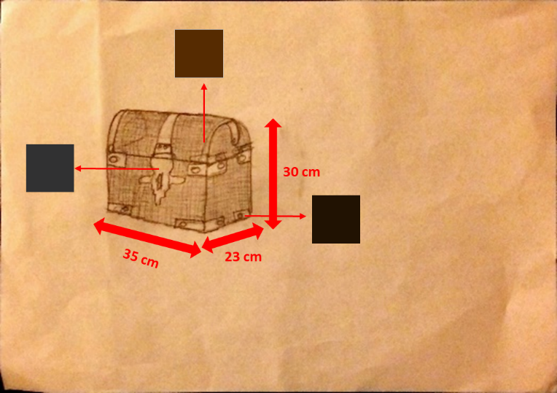

Lastly, the size for the model corresponds to **realistic real-life dimensions values**. This is important, as it helps measuring the scale for other models and how large other game assets should be.

With a high polygon count, the model’s file size may end up a little large. With that being said, the file may **take** some **time to render**.

As for the complexity of the model, I was hoping I could model a chest with the minimum amount of polygon count. However, due to the level of detail that may be required to successfully model a realistic treasure chest, I may end up exceeding the count I was aiming for.

**Barrel**

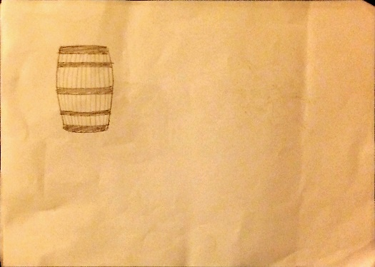A barrel is another game asset among the 3D models I will create. The player will enter a scene which consists of a partition that stores whiskey and wine oak barrels. This barrel will also have painted a strange message in its head. Almost immediately, the cask and all the other barrels will mysteriously start leaking, letting all the beverages spill. While all the spilled wine will not be enough to flood the cabin, it will surely cause panic to the player and that is the desired effect.

Figure 5. Barrel sketch.

In fact, the barrel is mainly for aesthetics. As this is a pirates’ ship, it also symbolises their love for drinking and matches the theme of the game.

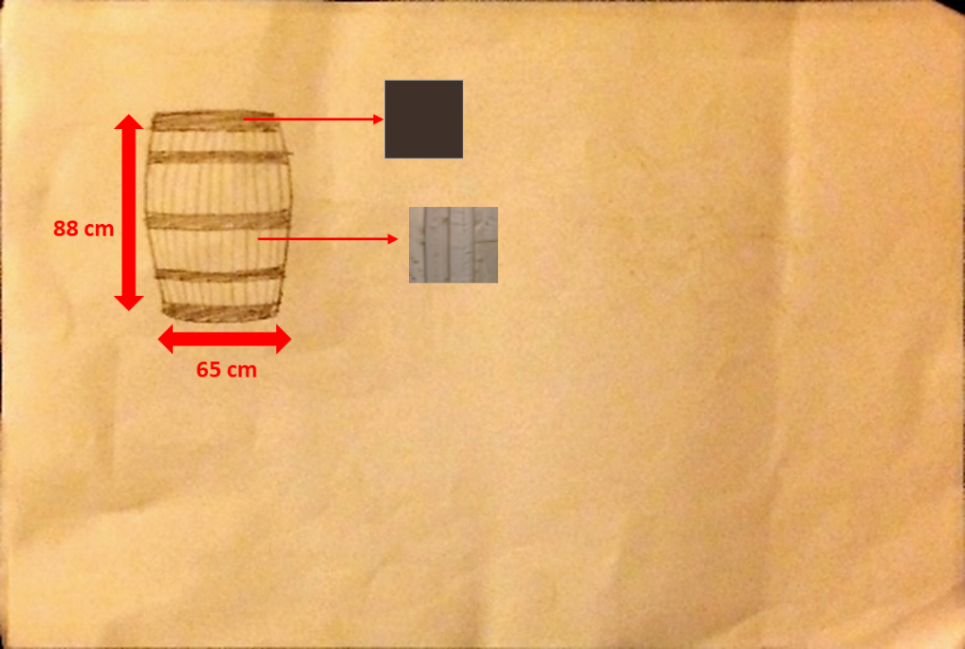

The barrel is a pretty simple object, with low polygon count and very simple to model. It probably will not require many face extrusions.

The wine oak barrel will have **solid dark brown coloured** hoops. As for the oak, I will use a wood texture for a wooden, realistic look.

**Ship helm**

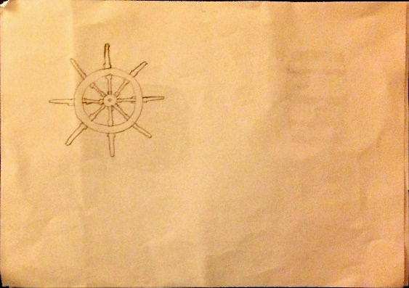The fourth model is a ship’s helm or wheel. It will be one of the last objects for the player to pick up. There will be a staircase that will lead the playing character outside the ship’s upper floor. This wheel is detached from its pedestal and platform, hence the player will need to bring it up and reassemble it to sail the ship and escape the remote island.

Figure 6. Ship wheel/helm sketch.

*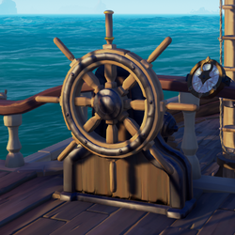Figure 7* is an example of what the helm steering wheel is supposed to attach to. This model is a standalone piece, and the player will have to assemble it onto its remaining structure.

The reason why I decided to create the helm separate from its platform was to confuse the player. Since the last note reads that ‘one must navigate the ship to flee’, the playing character cannot sail the ship without returning to the cabin and pick up the game object.

Figure 7. Ship's helm.

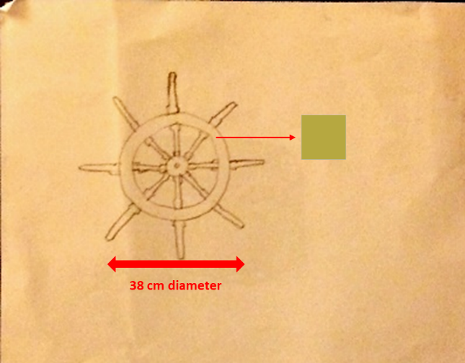

Even though it will be necessary quite a few face subdivisions, the helm is rather a simple model and surely will have a low polygon count.

It will have a diameter of approximately 15 inches (38 cm). *Figure 7* is just an example of what the helm would look like, thus it should not refer its target size.

The model will not have many colour details, but some real-life ship wheels have a solid colour paint. A wooden texture could still replace this option.

**Sword**

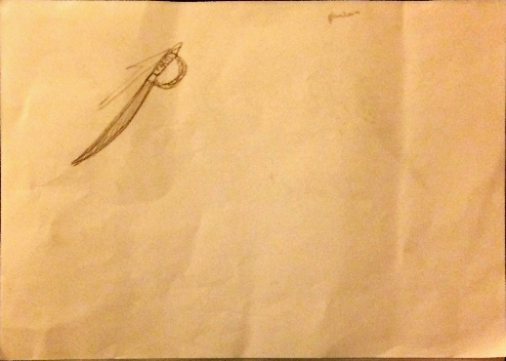The last model is a pirate sword.Initially, I was thinking of modelling a monocular telescope. At first it seemed a good idea, and the sketches proved it a quite simple model, but due to the complexity and detail involved in its creation, plus the lack of any particular use or relevance in the game, I decided to replace this and model a sword instead.

The pirate sword will serve as a weapon for the playing character to defend himself during a melee combat. A fierce storm will stir the ship while pale and limp creatures climb on and try to sink it. These creatures will try to sabotage the escape by taking advantage of the storm. However, they appear to be slow and not so smart, so they will not attack or defend. The player will have to use the sword to protect himself and knock them down until the wave ends.

Figure 8. Sword.

The pirate sword will have its pommel and hilt with an antique paint- if possible characteristic of that age. To emphasise its sharpness and glide, its blade will have a grey solid colour with a *Blinn* material for a shiny look.

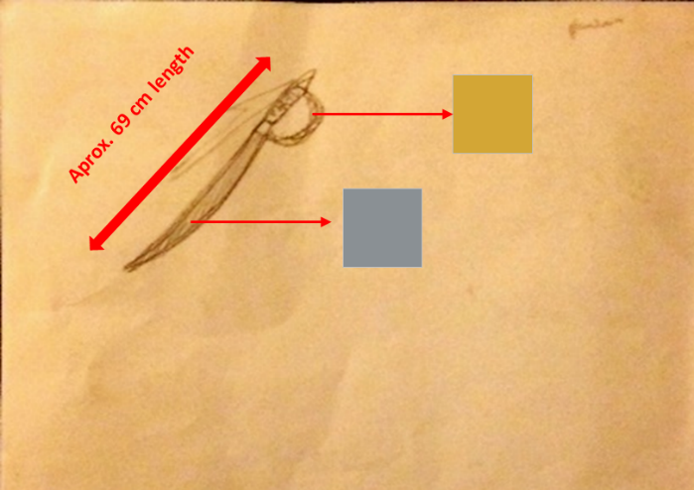

It seems to be the simplest model with the lowest poly count. There aren’t any constraints in terms of file size or render time.

It is a pirate themed game. Therefore the sword is supposed to resemble the Pirate Golden era. To better illustrate this, the weapon would have to be a curve-edged blade.

***Pirates Ship* logo**

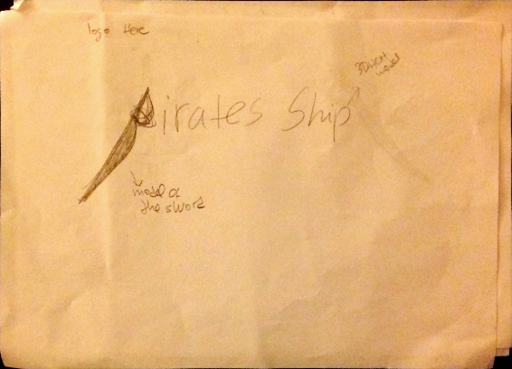At last, the logo will consist of the game’s name *Pirates Ship*. The letters that make up the logo will be 3D text models. In order to make it more interesting, the letter “P” will be replaced by the model of the sword, which quite oddly resembles it almost perfectly.

Figure 9. Pirates' ship logo/game title sketch.

When deciding the game logo, I initially had embraced the idea of creating a flag with skulls and bones. However, due to copyright reasons - as well the fact that the designs may disturb some players – I decided to discard the original concept.

Figure 10. Typical pirate ship flag.

**Gantt chart**



Figure 11. Gantt chart.

I have used a Gantt chart in order to plan and log my activity. From research to practical work, as well as how I was getting on with the unit tasks, this methodology helped me stay organised and record any progress in a weekly basis.

# Legal and ethical considerations

**Copyright**

Once designed and completed, the final products automatically receive a copyright license. I intend to make the assets library available online for download. Nevertheless, the models are still copyrighted and solely the legal owner can control the way the original work may be used by others.

Even though the models will be uploaded for public domain, the work is protected by copyright laws, hence conditions for their use may apply.

Game assets will be available for free, from the ‘*Game Engine*’ official website, for students and educators. This implies that assets may only be used for **educational purposes**. As long as the project is not to be commercialised, the student is allowed to make use of them.

With that said, others may need to be careful not to misuse any of the products as they offer protection against infringement. It is a criminal offence to adapt one’s work, publish it on the Internet unauthorised, copy it or distribute copies for either non-profit or profit purposes – unless there is no significant impact on the owner’s own business.

While there is definitely more flexibility in the use of the 3D models, **the game logo is the game’s trademark** **and shall not by all means be used as a logo for any other game but *Pirates Ship*.**

The infringer may be penalised by having to pay a £5000 fine or face up to 6 months in prison before a magistrates’ Court. In the Crown’s Court, the fine may be unlimited and the offender can end up staying in jail for a decade.

All 3D models/logos are unique and authentic products. Any similarity to other game assets - or their application in *Pirates Ship* - in relation to other games already released was not intentional.

The client made me sign a contract in which is stated that all technical ideas that I develop belong to the company, even those conceived while not on the job. Under the **confidentiality agreement**, I shall not disclose, make use of or copy the game assets designs and products to other clients or companies.

**Decency & Representation**

The designs for the models do not denote anything in particular that may upset some users.

For instance, the wine barrel model is a symbol of the pirates love for drinking. This could be enough to raise some eyebrows but its meaning is well hidden. However, a glass of wine would convey this meaning more loudly and offend those who view alcohol in a different way.

Among the game assets there is a weapon. As part of the game, players will need the sword so they don’t risk to fight empty-handed against the creatures of the sea. To avoid disappointment, producers will make an effort to advertise explicitly the nature of the game before they purchase. Users will be advised that some animated scenes can be disturbing, such as fight and killing. This object is not trying to promote **violence** but simply illustrating the Golden Age of Piracy as well as the culture that comes along with it.

All models represent objects that the playing character will need to progress in the game. These have a practical purpose and are completely non-discriminatory. The assets don’t meant to determine a person’s gender or sexuality, nor offend a person’s race or religion. The designs/models are in no way trying to disrespect any ethical and moral values and principles.